Crop Yield Estimation Plugin – Quick Guide

- Introduction

Yield Prediction Plug-in can perform parcel-based crop yield and biomass prediction using classified agricultural parcels and multi-temporal SAR imagery. It includes machine learning regression algorithms such as Support Vector Machine (SVM) and Random Forest (RF), where users can perform yield prediction using VV and VH SAR(Synthetic Aperture Radar) datasets. Prior to performing yield estimation, raster and vector datasets generally require complex preprocessing and zonal statistics extraction. However, the Yield Prediction Plug-in allows users to provide fewer inputs and generate predicted Yield and Biomass outputs along with validation metrics through its integrated preprocessing and prediction workflow.

- Plugin Installation
- Open QGIS. Go to Plugins in the Menu bar click on Manage and Install Plugins.
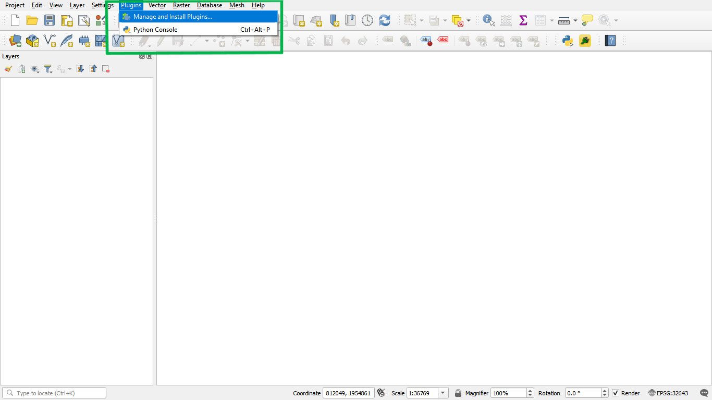
- Now click on Install from ZIP Install Plugin in the right panel Load the Yield Predictor.zip and restart the QGIS.
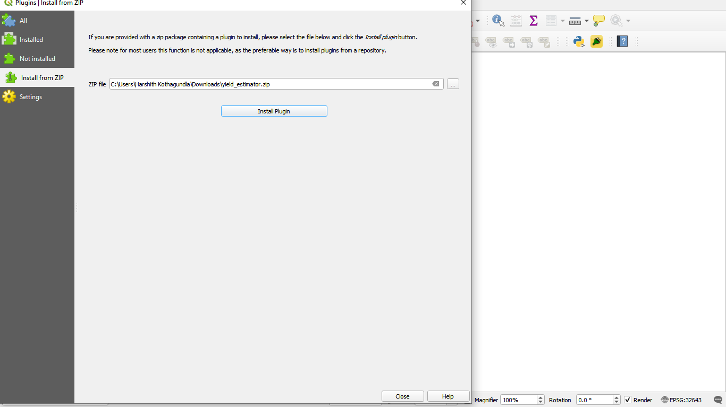

- Finally, the plugin has installed and plugin icon appears on the top panel bar.
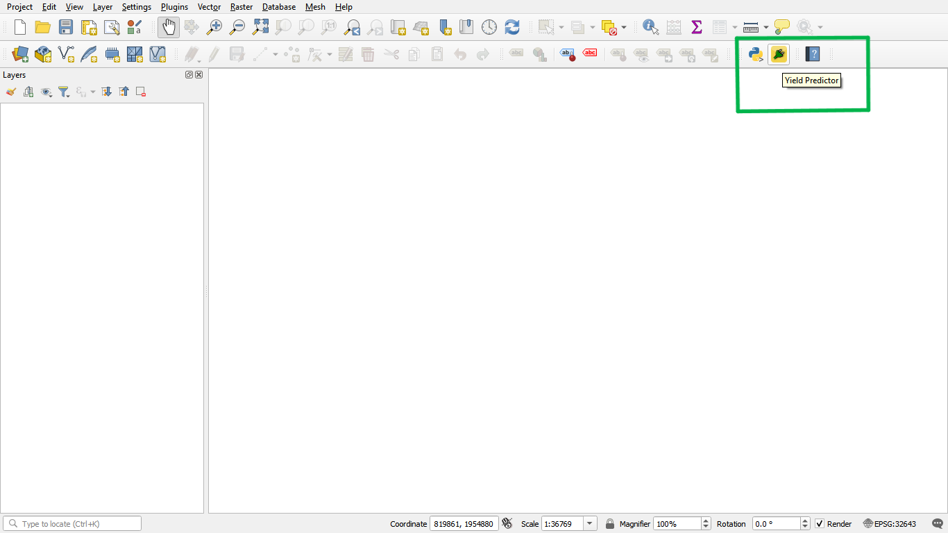

- Click on that plugin icon and new dialog box named Yield Predictor will open (as shown below)
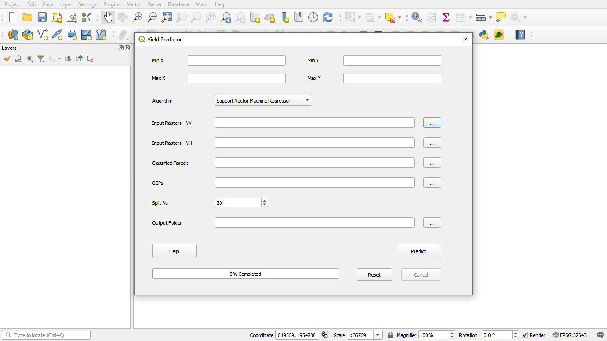
- Dependencies / Requirements
Before running the Yield Prediction Plug-in, ensure the following dependencies and requirements are properly configured in QGIS.
Required Python libraries:
  - NumPy
  - Pandas
  - Rasterio
  - GeoPandas
  - Rasterstats
  - Scikit-learn
  - Matplotlib
  - Shapely

- Plug-in Design & Workflow

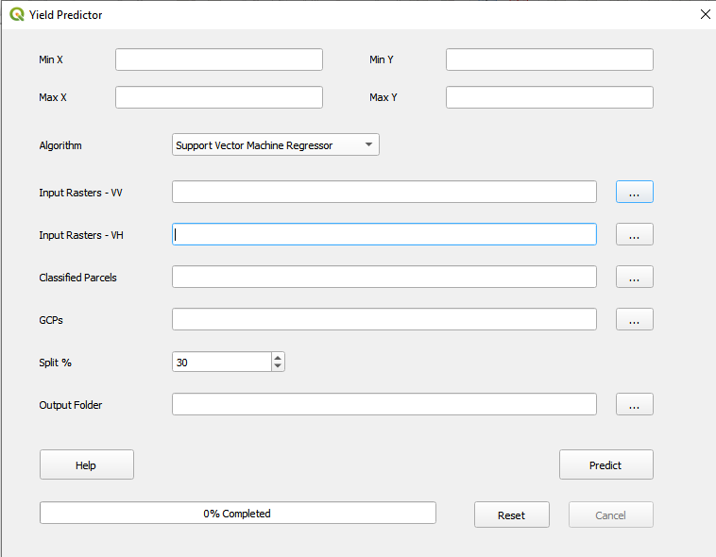
7
5
6
4
2
3
1

  - Design&Inputs
- Algorithms
Users can select either Random Forest (RF) or Support Vector Machine (SVM) regression algorithms to perform parcel-based crop Yield and Biomass prediction using multi-temporal SAR imagery
- Input Raster-VV
Select multiple SAR satellite raster images with VV polarization acquired on different dates as input for crop Yield and Biomass prediction. Supported format: .tif
- Input Raster-VH
Select multiple SAR satellite raster images with VH polarization acquired on different dates as input for crop Yield and Biomass prediction. Supported format: .tif
- Classified Parcels
Select the classified crop parcel map obtained from ML-CLAS or any other reference crop parcel dataset. The input SAR raster images will be clipped to these parcel boundaries and parcel-level zonal statistics will be computed for Yield and Biomass prediction. Supported format: .shp
- Field Samples
Provide ground truth sample data containing Latitude, Longitude, Crop Type, Biomass, and Crop Yield information for model training and validation. Supported format: .csv

- Split
Specify the percentage of field sample data to be used for validation (testing). The remaining data will be used for training the machine learning model.
- Output Folder
Select the directory location where all generated outputs including predicted Yield, Biomass, and validation reports will be saved

4.2 Workflow
Input SAR Images (VV & VH)
↓
Load Classified Parcel Boundaries
↓
Provide Ground Truth Field Samples
↓
Select Regression Algorithm (RF / SVM)
↓
Automatic Preprocessing
(Raster Clipping & Parcel-based Zonal Statistics)
↓
Feature Extraction from Multi-temporal SAR Data
↓
Train-Test Data Split
↓
Model Training & Validation
↓
Crop Yield & Biomass Prediction

↓
Accuracy Assessment
↓
Generate Outputs
(Predicted Yield, Biomass & Validation Reports)

- Results
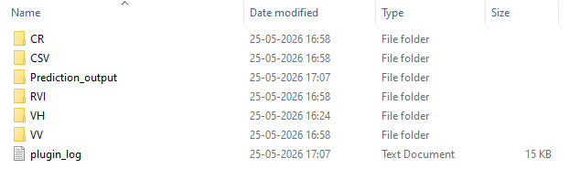
Output Folder

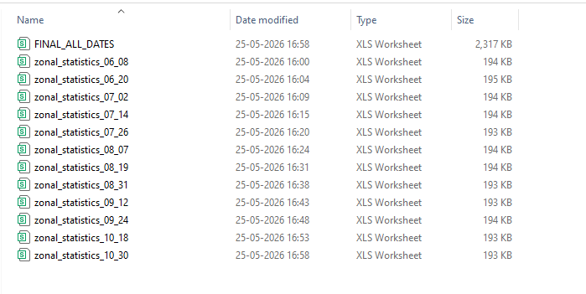
Zonal statistics present in CSV folder

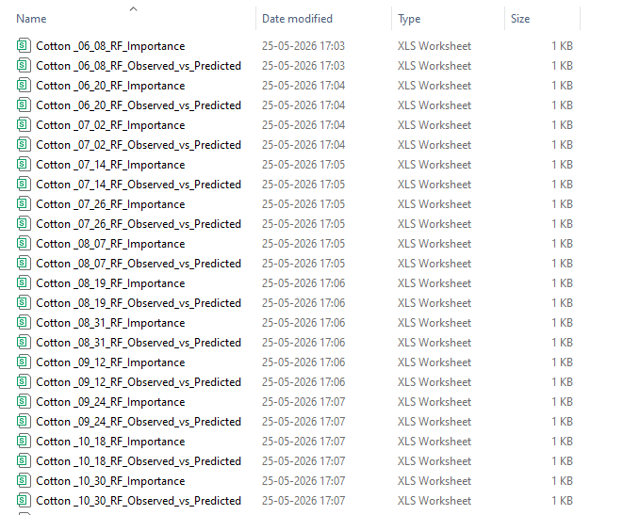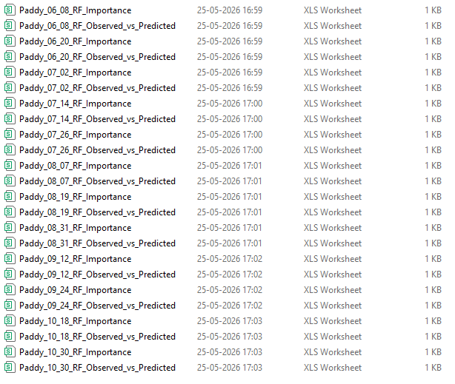
Day wise Yield predictions of Cotton and Paddy present in prediction output folder

